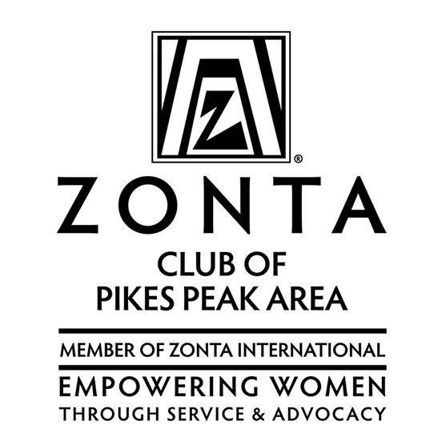
At a General Membership Club meeting, October 2014
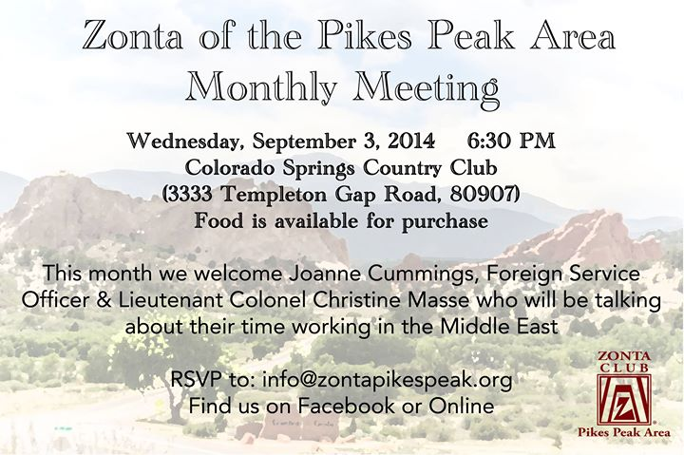
Typical PPA meeting announcement
On March 31, 1949 the charter dinner for the Zonta Club of Colorado Springs was held at the Broadmoor Hotel with 19 charter members. The charter was presented to the new organization by Helen Anderson of the Denver Chapter. She and 22 members of the Denver club chartered a plane and flew to Colorado Springs to attend the dinner. Within two years, the new club was well on its way with a variety of fund-raising activities and local and international service projects. The first service project was completed in June of 1949, when funds were raised to grant five camp memberships to underprivileged girls. A second service project was started in 1950, funds being raised for scholarships for young women wishing to study at the nursing school of Memorial Hospital. Monies were raised through rummage sales, candy sales, card parties, and selling Christmas paper napkins. The Colorado Springs Zontians felt strongly about women’s education and continued to raise funds for full-year scholarships to nursing students at Beth El, and further contributions to Penrose student nurses. In 1956, during the Sunday morning breakfast of the District 12 conference, held at the Broadmoor Hotel, Vice President Richard Nixon and wife, Pat, stopped by. Mr. Nixon spoke informally expressing his interest in the Zonta Club and stressing his belief in the value of such service organizations and the value of women in government. In 1967 a plea by the American Red Cross for community groups to produce “friendship kits” for displaced Vietnamese children went out. The Zonta Club was one of the first to respond. The need for these kits was great—the request numbering in the hundreds of thousands. In 1970, the club raffled off a beautifully refurbished dollhouse, and continued restoring donated doll houses for several years. The proceeds were used to benefit the students at the Colorado School for the Deaf and Blind and the Rocky Mountain Rehabilitation Center.
In 1985, another club was established, the Pikes Peak Area Zonta Club, by Aiko Sturdevant and Anne Taussig. Aiko served as its first president, having previously brought her Japanese culture to citizens of the Colorado Springs via performances of dance, flower arranging and tea ceremonies held at schools, and costume design for Madame Butterfly in Colorado Springs and Denver. Among the projects supported by the new club were annual travel grants provided to foreign graduate students in the Summer Crossroads Program at Colorado College. The two clubs merged in 1992, keeping the 1949 charter and the Pikes Peak Area name. Its first president was Betty Hudson. The “new club” continued to fund and to choose a recipient for a previously established local Zonta scholarship for an underprivileged woman desiring to complete a university degree, and would mentor that woman through her years of schooling, its members often providing personal advice and tutoring to the student(s).
The Colorado Springs Club had already established itself as host of the annual Mother’s Day Luncheon and Fashion Show. The fashion show was held in 1977 at Peterson’s Air Force Base Officer’s Club. The proceeds went to Silver Key, Lone Feather Council and the Colorado Deaf & Blind School. In later years the event was held at the prestigious Broadmoor Hotel. (This event was continued by the Pikes Peak Area Club after it was discontinued by the Colorado Springs Club, and then again continued for several years after the merger of the two clubs.) The event was both a fund-raiser and a way to spread information about the Zonta Club and to attract new members, as well as celebrate motherhood with prizes, including one for the oldest mother/grandmother at the luncheon. Local businesses would send models wearing that spring’s new fashions, and raffle tickets were sold (the winners received items contributed by local businesses and members).
After the two clubs merged, the members decided that this event did not produce as many funds and as much publicity as the club desired, and so, with the help of Debra Dion Krischke, owner of Team Effort Events and member of the Zonta Club of Pittsburgh, the Glass Slipper Ball was established in 2005. The yearly event attracts hundreds of men and women, and features local chefs and florists who compete for prizes for their special dishes and centerpieces. The event includes live music and dancing, a silent auction and a live auction. The Glass Slipper Ball concept was transferred to Laura Stamp, Pikes Peak Area member and local business owner, and continues to be our major fund-raiser, with club members continuing to participate in promotion, preparation, etc., but with the event running as a separate business. In 2013 the club contributed about $24,000 to local and international projects, with about half of that coming from the Glass Slipper Ball, and the rest of the funds from nut sales, other fundraisers and private donations.
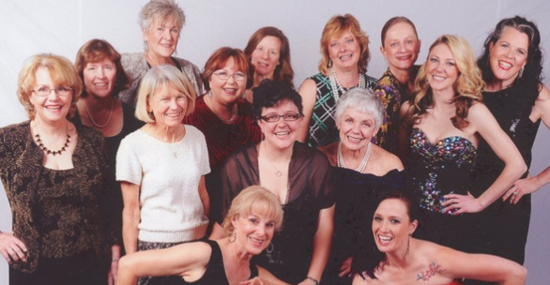
PPA Club Members at the GSB 2014 (Kirkland Photography) Typical GSB image
The Zonta Club of the Pikes Peak Area has continued the work of service to its local and international communities with projects that more directly speak to improving the status of women. Many of the members have served as Area 4 Directors, held District Board positions, and one member, Betty Edwards, served as District 12 Governor from 2000-2002. The Pikes Peak Area Zonta Foundation was established in 2009 and is organized exclusively for charitable purposes, to carry out the charitable objectives of the Zonta Club of the Pikes Peak Area of El Paso County, including the provision of service at the global and local level and to support charitable organizations that advance its objectives. And the club is the springboard for two important area events, the Human Trafficking Task Force, established in 2008, which meets monthly and collaborates with other groups, such as the Colorado Springs police, in research, action and raising awareness; and the local celebration of International Women’s Day, an event which raises awareness of women’s issues via featured speakers (local, national and international). Zonta of the PPA has taken the lead in establishing the Planning Committee for the Colorado Springs International Women’s Day Celebration since 2011. This event is a collaborative effort of and/or sponsored by several local organizations, including the Zonta Club of the Pikes Peak Area, Soroptimist International of Colorado Springs, the American Association of University Women/COS, the local World Affairs Council, and the Women’s Resource Agency. This event is open to the general public and has grown each year, hoping to attract 175 participants in 2015. The event was moved to elegant Pinery on the Hill in downtown Colorado Springs in 2014, and includes brunch and live music by a local group, as well as five local, national and/or international speakers.
In 2017 the IWD theme, “Women Empowered by STE@M” (STEM, Science, Technology, Engineering and Math, plus @ for the Arts), inspired the formation of a new grassroots effort, the Women’s STEM Careers – Southern Colorado Committee, which hosted its first event, “Women in STEM: Exploring and Equipping,” in partnership with the PPA Zonta Club and the Space Foundation at the Space Foundation Discovery Center in 2019.
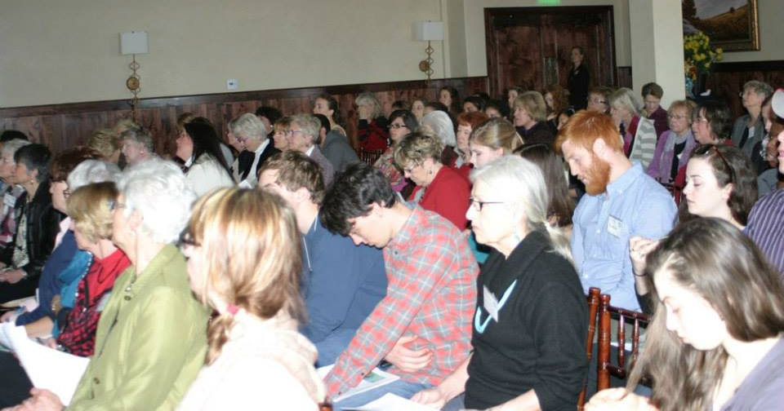
IWD, Colorado Springs, 2014
In the legislative area, the club was instrumental in advocating for a state law prohibiting the practice of female genital mutilation in the state of Colorado, a process spearheaded by club member Karen Pauley, the club having been inspired after reading several books on the subject together, including Possessing the Secret of Joy, by Alice Walker.
For many years our members have also volunteered in a wide range of other community activities, including highway clean-up, soup kitchen, care baskets, assisting immigrant families, collecting cell phones and other items for women’s crisis and support groups, and more. Local groups receiving help and/or funding from the Pikes Peak Club include TESSA, the Women’s Resource Agency (and its program, Intercept), the Human Trafficking Task Force of Southern Colorado, the Red Cross Shelter, Full Circle, Leadership Pikes Peak Women’s Community Leadership Initiative (WCLI), Centro de la Familia, Trampled Rose (eradicating fistula and educating girls in Ethiopia), etc. Within the club, small groups and activities serve to mentor new members (the “New Z’s”) and to get to know and support each other, including ice cream socials, holiday dinners, etc. Information is shared within the group and with others via emails, a website and Facebook. The club contributes a third of its funding to Zonta International projects. We regularly award our Young Women in Public Affairs award to an outstanding local high school student, and were proud that our most recent recipient, Audra Burke, went on to receive the 2014 Zonta International Young Women in Public Affairs award.
Audra Burke
In 2017 the club launched its newest annual fundraising event, the Pikes Peak Trivia Night, featuring trivia questions unique to the Pikes Peak and Colorado Springs history, culture and geography. The club also mourned the loss of the founder of this event, and established the Shannon Rowan Memorial Fund, dedicated to helping young women aging out of the foster home system.
The club advocates for women throughout the year via its three Facebook pages, Zonta Pikes Peak, International Women’s Day – Colorado Springs, and Women’s STEM Careers – Southern Colorado, in addition to its website and the International Women’s Day page.
Pikes Peak Area Zonta website: http://zontapikespeak.org/ Human Trafficking Task Force website: http://ht-colorado.org/
Colorado Springs Glass Slipper Ball website: http://www.glassslipperball.com/colorado-springs
The local celebration of International Women’s Day: http://www.iwd-coloradosprings.org/
Information on Audra Burke, our local and international recipient of the YWPA: http://www.zonta.org/Portals/0/PDFs/New%20PDFs/2014%20YWPA%20Recipient's%20Bios%20with%20photos.pdf

Colorado Springs Club and Pikes Peak Area Club documents are archived at the Penrose Library, downtown Colorado Springs http://ppld.org/penrose-library

