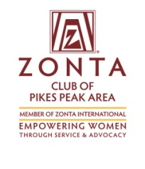
Zonta’s Pikes Peak Trivia Night
Registration Form
Venue: International Dance Club
2422 Busch Ave. - Colo. Springs
Date: Friday, Oct 12, 2018
Time: Check in, Social Time and Silent Auction: 6:00 – 6:30
Trivia Game: 6:30 – 9:30 PM

Register as a team of 8 or as an individual. Maximum of 8 (eight) members to a team. For those without eight team members, we can help you fill in the remaining openings in your group.

Team:
Team Name: __________________________
Team Captain: _________________________
Address : _________________________________________________________
Phone: ______________________________ Email: _______________________

Team Members:
1.________________________ 5.________________________
2.________________________
3.________________________
4.________________________
6.________________________
7.________________________
8.________________________

Individual Registration:
Name: __________________________
Address: __________________________________________________________
Phone: __________________________ Email: ___________________________
Please assign me to a team with ______________________________________
___ Check if non-player / cheerleader

Tickets: $20 in advance
$25 at the door
__________$160 Per Team (eight players maximum) or
__________ $20 per individual Total amount Enclosed: __________
Payment: Mail completed registration form and check to PO Box 7924
Colorado Springs, 80933 or register online at zontapikespeak.org/trivia
Mail In registrations must be received by October 10th.
Refunds for this event cannot be guaranteed.

