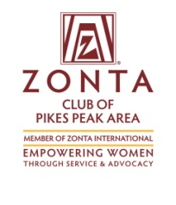
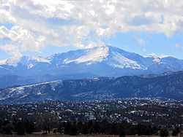
Zonta’s Pikes Peak Gold Trivia Night

Come and Play to Support Women’s Initiatives Locally and Globally

Win Great prizes  1st place --$500  2nd place –a gift basket worth $300  3rd place –a gift basket worth $200  Prizes for the winners of every round!  Registration includes:  Trivia game and opportunities to win fabulous trivia prizes.  Additionally, you may wish to take advantage of great deals at our Silent Auction, purchase a “Mystery Gift,” Play 50/50 for a chance to win 50% of the cash generated by that game or test your luck at Truth or Fiction for another chance at a fantastic prize.  Non- alcoholic beverages, wine, beer and food are available for purchase |  | Venue: International Dance Club  2422 Busch Ave. - Colo. Springs  Date: Friday, Oct 20, 2017  Time: 6:30 – 9:30 PM  Tickets: $20 until Oct.13  $25 at the door  Team Table : $160  Single player: $20  For more information:  Contact the Zonta Club at info@ZontaPikesPeak.org  Register online at zontapikespeak.org/trivia  Or send downloaded reservation form and a check to:  PO Box 7924  Colorado Springs, 80933
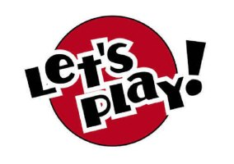

Proceeds will benefit: Zonta Wings and Launching Families, plus:
The Trampled Rose, Zonta Scholarships, Women's Resource Agency, Human Trafficking Task Force
TESSA, Women's Community Leadership Initiative (Leadership Pikes Peak), Centro de la Familia, and Zonta International. Sponsorships may be paid on-line at Zontapikespeak.org/trivia

