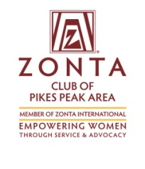
Zonta’s Pikes Peak Gold Trivia Night
Registration Form
Venue: International Dance Club
2422 Busch Ave. - Colo. Springs
Date: Friday, Oct 20, 2017
Time: Check in, Social Hour and Silent Auction: 5:30 – 6:30
Trivia Game: 6:30 – 9:30 PM

Register as a team of 8 or as an individual. Maximum of 8 (eight) members to a team. For those without eight team members, we can help you fill in the remaining openings in your group
Team:
Team Name: __________________________
Team Captain: _________________________ Address: ___________________
Phone: ______________________________ Email: _______________________

Team Members:
1.________________________ 5.________________________
2.________________________
3.________________________
4.________________________
6.________________________
7.________________________
8.________________________

Individual Registration:
Name: __________________________
Address: _________________________
Phone: __________________________ Email: ___________________________
Please assign me to a team with ________________________________

Entry Fees: Due by Oct 13 for the Early bird price
Tickets: $20 by mail or on line by Oct.13
$25 after Oct. 13 OR at the door

__________$160 Per Team (eight players maximum) or
__________ $20 per individual Total amount Enclosed: __________
Payment: Mail completed registration form and check to PO Box 7924
Colorado Springs, 80933 or register online at zontapikespeak.org/trivia
Refunds for this event cannot be guaranteed.

